New Photo

Project Overview
You are to create a short presentation that has 3 slides. The slides will be a short show about your favorite topic. Each slide is a composite of several parts of many pictures. You are to create new photos that never existed before.

Student Objectives: Each student should be able to perform and demonstrate the following once completing this project:

- Alter pictures (using Paint) to suit the needs of the project and copy and paste back into Power Point
- Find pictures quickly as needed for any project
- Copy and Paste objects from the Internet into Power Point
- Insert objects into slides

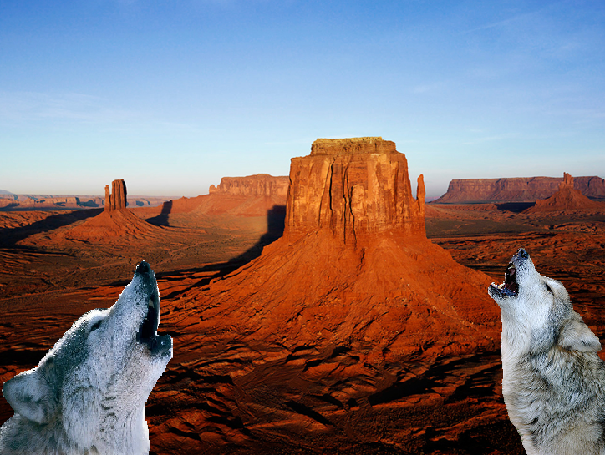



Wolfee calls for a friend Friend Calls Back They Play All Day Long

Directions: Create a short presentation that shows your story.

Requirements:
- 3 slides long
- Each slide must be a new photo that never existed. Add 2 parts of other pictures to the main scene.
- No square graphics
- Make the additions able to be seen
- Make the additions clean: no white fuzzies around it
- No pixelized pictures: pictures should be sharp not difficult to see

