Trigger Project

Directions: Create a one slide presentation that uses triggers to launch various objects to an existing picture. See the example: trigger house on computer class documents. You can pick from the following or make up a topic of your choice:
House
Barbie Doll
Dinner Table
Ice Cream Cone
Carved Pumpkin
Car
Christmas Tree
Computer

You need to have 10 items (The picture shows 5 only. “Red Roof” and the blue square-“RR” count as 1 item) that can be triggered with a way to remove the item. For example, click the following:

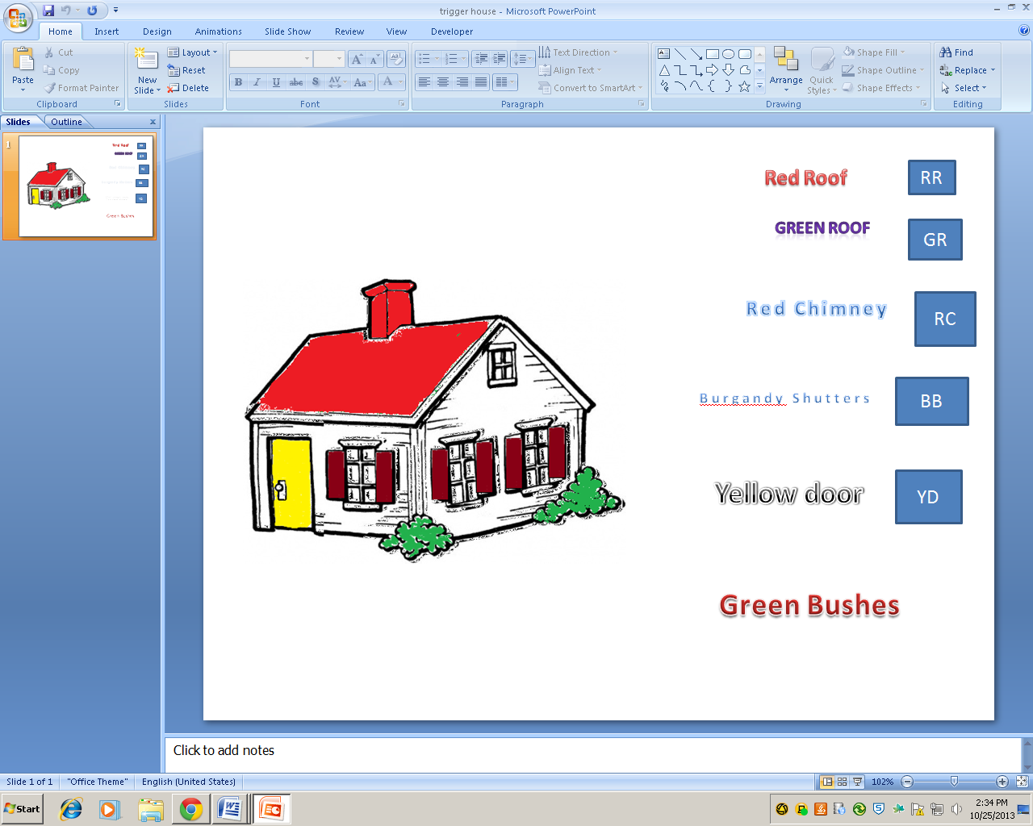

Click on the Words “Red Roof” to launch the Red Roof and click the blue rectangle labeled “RR” to remove the red roof. See next page

Important: You can have 2 new colors to choose from. The last 8 triggers should bring on new objects. Look at the house above. I am changing the colors. I want to be able to bring on something that is not showing. For example, a fence or garage.

