Grade 7
My Life Story

Directions: Create a PowerPoint presentation about your favorite sports team, hobby, fairy tale, life story, etc.

This presentation is only 3 slides long.

- The front cover

  - 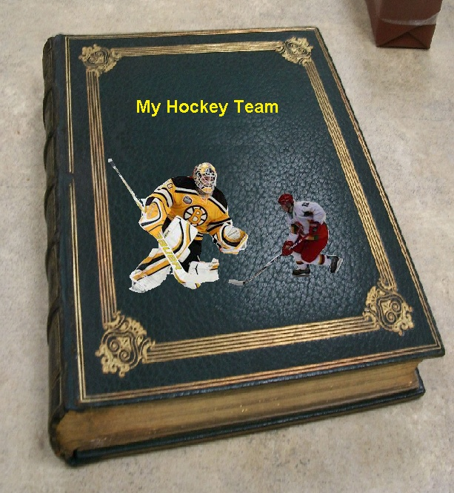

  - Requirements: 2 pictures and a Title

- Page 1 and page 2

  - Requirements: open book, 2 pictures and a few words

- Back Page

- 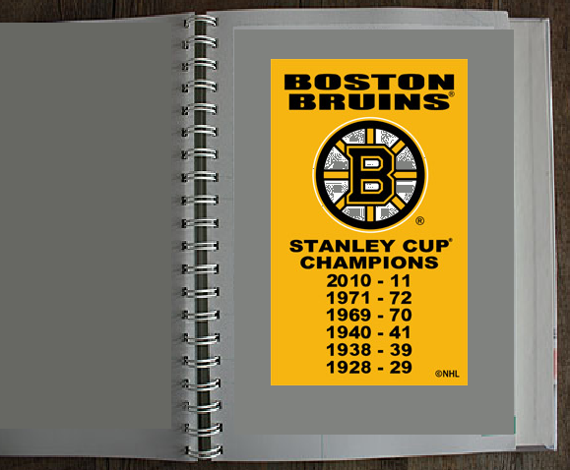

  - Requirements: Back page, 1 picture, few words
  - NO SQUARE GRAPHICS. YOU MUST “CLEAN UP” THE PICTURES.
    - Look at this picture.
    - Notice that It is square or rectangular. Not accepted. The pictures must have some curve to the m. See the pix from the book cover.

See next page
  - Disaster Recovery
    - When you are finding your pix from the internet, make sure you save them to Power Point. You then save the file. You will always have the pix available in case of disaster.
  - When I Grade the project, you must show me you’re Power Point that has all of the Pix that you saved. I need to know that you have practiced “Disaster Recovery”.

