Jeopardy
Power point
Directions: Create a jeopardy game using power point. Create a game for Spanish, Math, Science, etc.
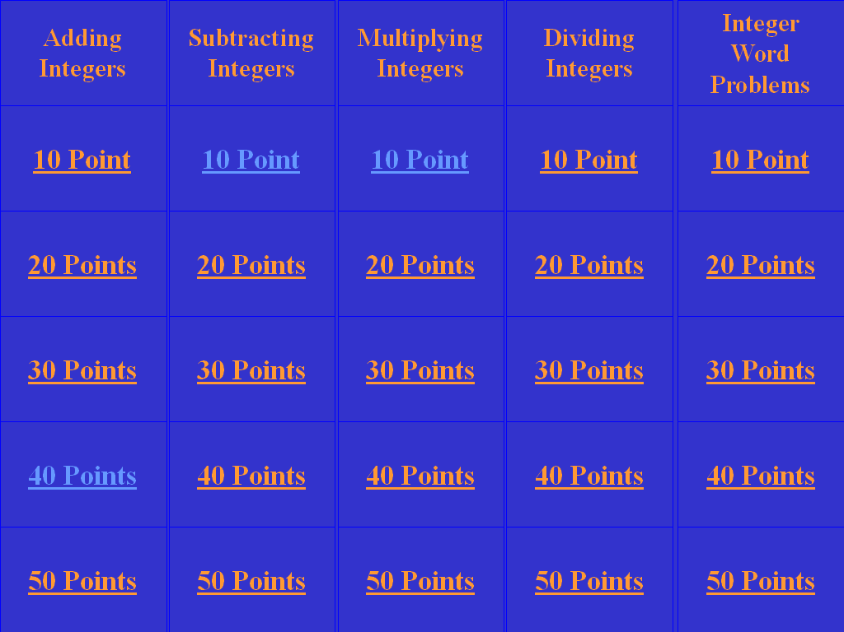
The start of the game should look like this below. Choose the categories that you prefer.

- The player needs to be able to click on any of the points that they want.
  - The above game has 25 questions
- When they click on one, the computer sends them to a slide that has the question similar to below.
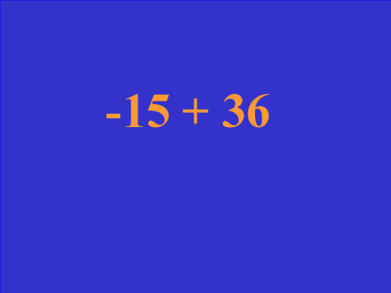

- When the player thinks they know the answer, they can click on the above slide to send them to another slide that gives the correct answer

- From there, the player can click on the answer and power point will send them back to the main game screen

