Directions to install Microsoft Office

Note: Microsoft has allowed the free install of Office to students and teachers.

- Google search “sign in to Office 365
- You should get this screen below
  - Click here
  - Your screen should look like this below:
  - 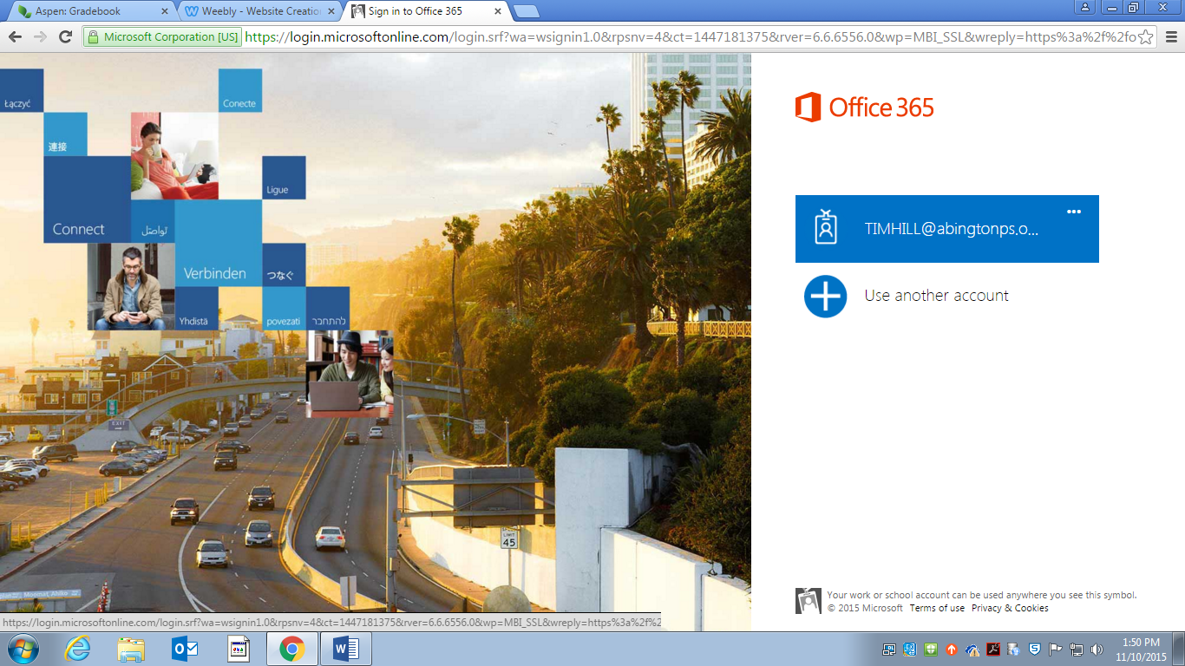

- Signing In
  - Type the student login name (the same one used to login to the network at school-should be on the inside front cover of the agenda)
    - Follow the student name with: @student.abingtonps.org
    - Example: johndoe@student.abingtonps.org
  - Password: the password is the same as that used in school
- Select the time zone and save your settings

- You will see your new e-mail account’s main page
  - Your page should look like this:
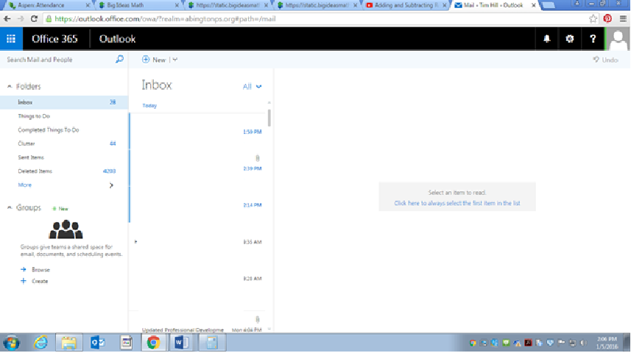

- In the upper right corner, click on the icon that looks like a wheel

- Your screen should look like this:

- Click on Office 365 Settings

- Your screen should look like this:

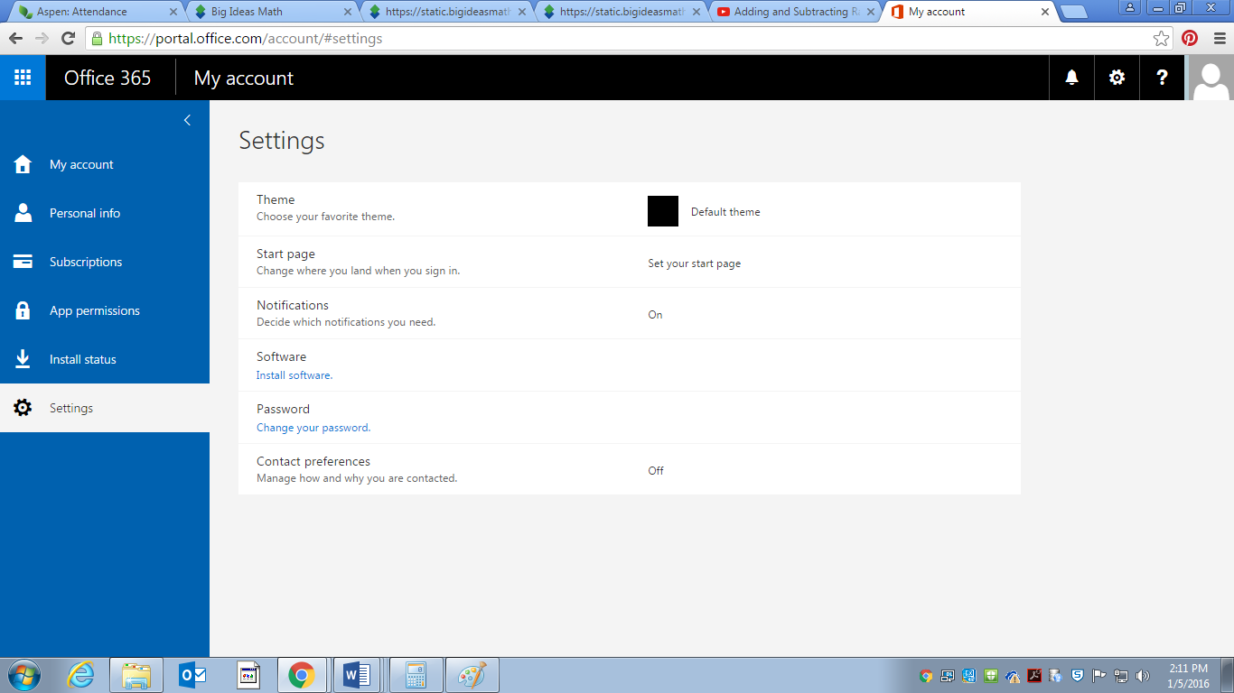

- In the middle of the page, Click on Install Software
- Your screen should look like this:

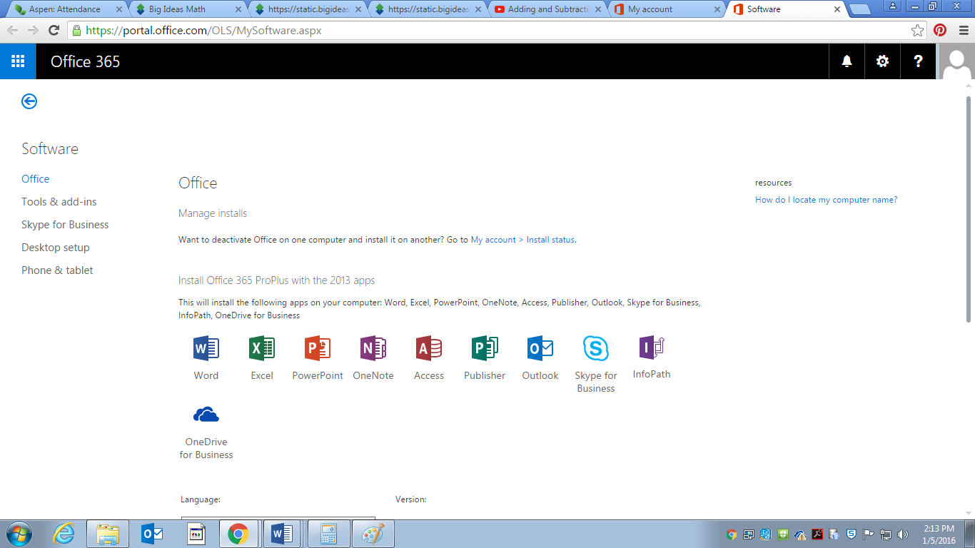

- On this screen, scroll down just a little so you can see this:

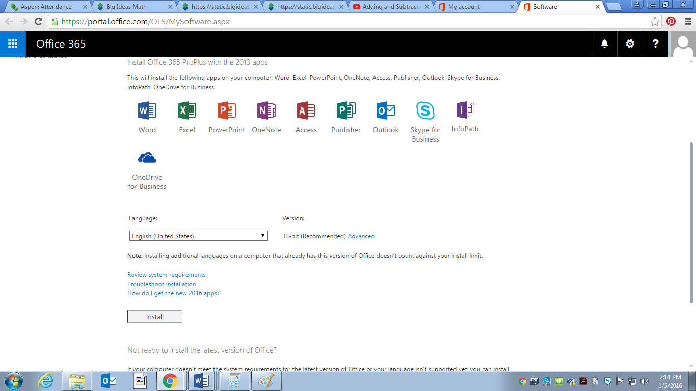

- Click on Install
  - Office should be installing at this point
- Note: when you go to use the applications, it may ask you to login

  - Just login the same as you would if logging in to the school computers

